**1. Banking System Globalization in the US Banking Sector**

**2. Financial Inclusion Initiatives in the US Banking Sector**

**3. Emerging Trends in the US Banking Sector**

**(Presented By Alan Stuart K)**

**1. Banking System Globalization in the US Banking Sector**

**Introduction:**

The US banking sector has traditionally held a dominant position in the global financial system. However, recent decades have witnessed a growing trend of globalization, with foreign banks entering the US market and US banks expanding their international presence. This report explores the implications of globalization for the US banking sector, analysing its impact on competition, risk, and innovation.

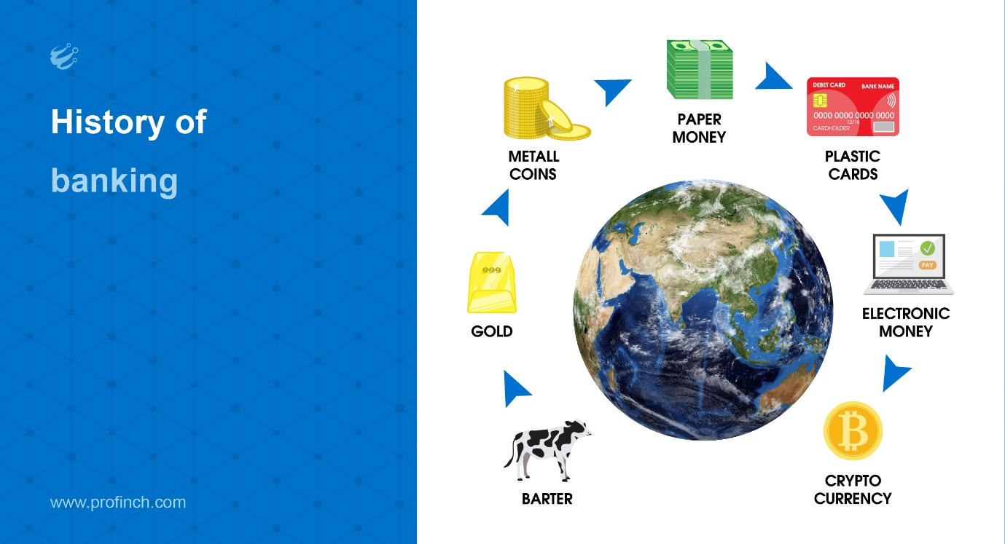

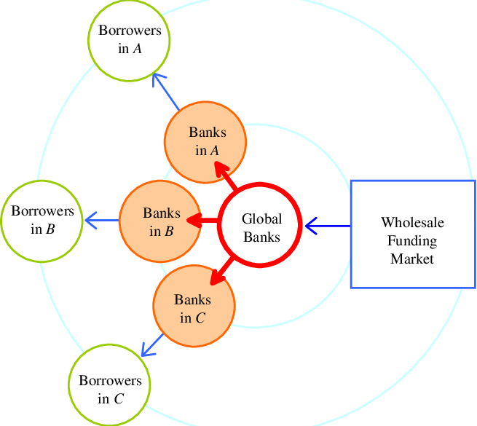

**Rise of Foreign Banks in the US:**

* **Entry of Foreign Banks:** Since the 1980s, deregulation and liberalization measures have facilitated the entry of foreign banks into the US market. These banks offer competition to domestic institutions, particularly in areas like corporate and investment banking.

**Data Point:** According to the Federal Reserve Bank of St. Louis, foreign banks held over $7 trillion in total assets in the US by 2022, representing a significant share of the market.

* **Benefits of Competition:** Increased competition from foreign banks can lead to lower interest rates on loans and higher interest rates on deposits for US consumers and businesses.
* **Challenges for Domestic Banks:** Domestic banks may face pressure to improve efficiency and innovation to compete effectively with foreign players.

**US Banks Going Global:**

* **Expansion Abroad:** US banks have also expanded their international reach, offering a wider range of financial services to businesses and consumers worldwide. This allows them to diversify their revenue streams and tap into new growth markets.

**Data Point:** A report by the Institute of International Finance indicates that US banks held over $20 trillion in foreign assets by 2022, highlighting their significant global footprint.

* **Benefits of Expansion:** Global expansion can provide US banks with access to a wider pool of capital, talent, and business opportunities.
* **Risks of Expansion:** Operating in foreign markets exposes US banks to currency fluctuations, political instability, and unfamiliar regulatory environments.

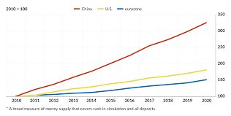

**Impact of Globalization on the US Banking System:**

* **Increased Risk:** Globalization can expose the US banking system to interconnectedness risks. Issues in one part of the world can have ripple effects on other markets, potentially amplifying financial crises.
* **Regulatory Challenges:** Effectively regulating a globalized banking system requires international cooperation and coordination among regulatory bodies to ensure financial stability.
* **Innovation and Efficiency:** Globalization can foster innovation as banks compete for market share and develop new products and services tailored to diverse customer needs.

**Case Study: The 2008 Financial Crisis:**

The 2008 financial crisis highlighted the interconnectedness of the global financial system. The collapse of Lehman Brothers in the US triggered a domino effect, impacting financial institutions worldwide. This event underscored the need for robust risk management practices and international cooperation to mitigate systemic risks.

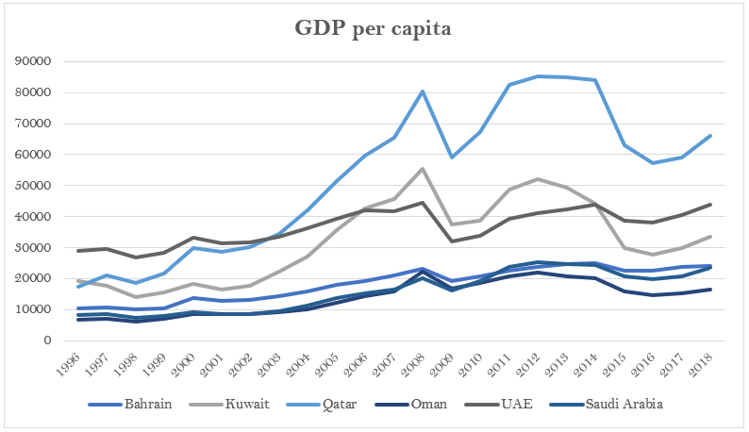

**The Road Ahead:**

The future of banking system globalization in the US remains uncertain. Regulatory developments, technological advancements, and global economic trends will all play a role in shaping this landscape. However, it is likely that globalization will continue to influence the US banking sector, presenting both opportunities and challenges.

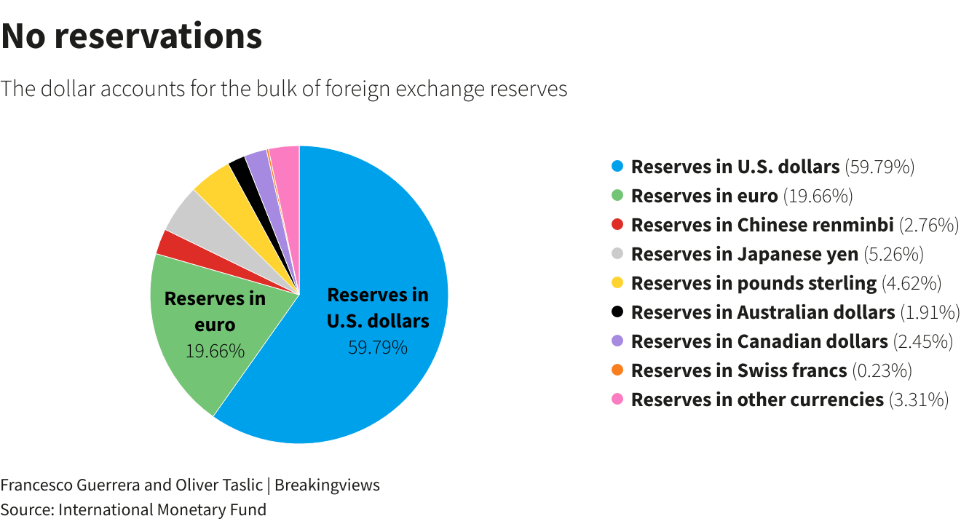

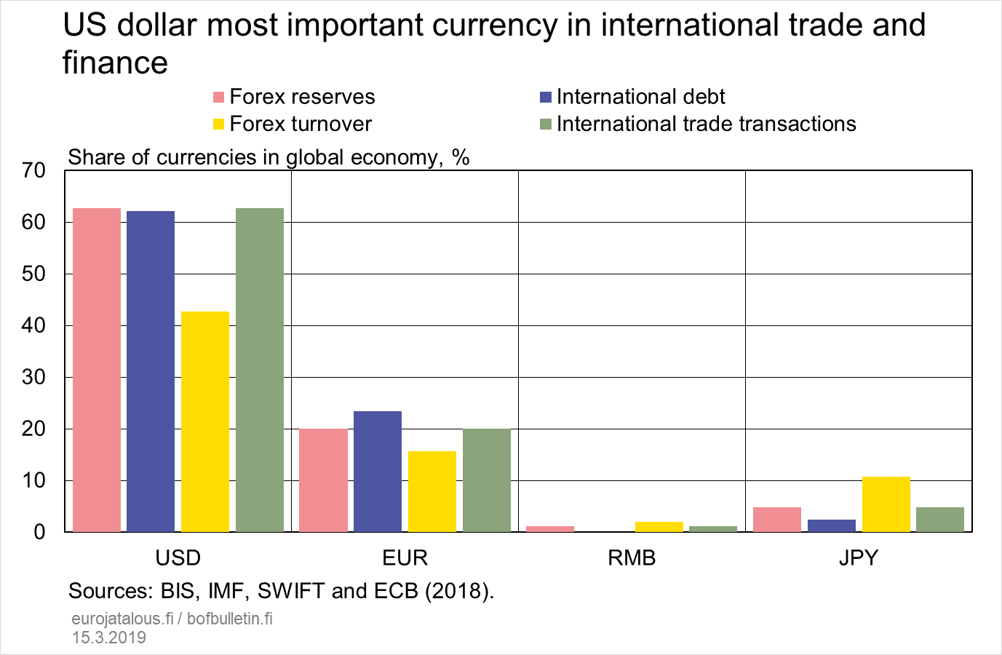

**2. Financial Inclusion Initiatives in the US Banking Sector**

**Introduction:**

Financial inclusion refers to ensuring that everyone has access to affordable and useful financial products and services. This includes basic banking services like checking and savings accounts, as well as credit, money transfers, and insurance. Unfortunately, a significant portion of the US population remains unbanked or underbanked, lacking access to mainstream financial services. This report examines various initiatives aimed at promoting financial inclusion in the US banking sector.

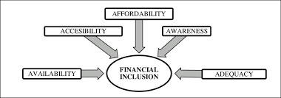

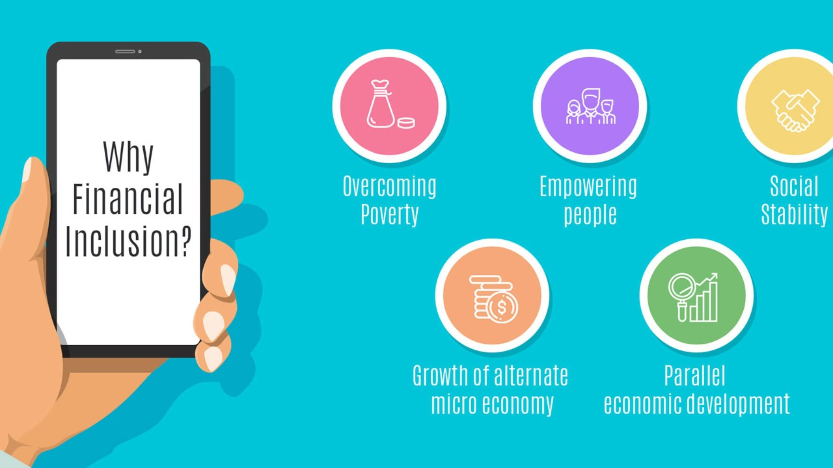

**The Scope of the Challenge:**

* **The Unbanked and Underbanked:** According to the Federal Deposit Insurance Corporation (FDIC) [1], approximately 5.8 million US households were unbanked in 2021, meaning they did not have a checking or savings account at a bank or credit union. Additionally, many more are underbanked, relying on alternative financial services like payday lenders, which often come with high fees and predatory practices.

**Data Point:** A study by the Pew Research Centre found that in 2021, 14.7% of US adults were either unbanked or underbanked, highlighting the prevalence of limited financial access.

* **Causes of Limited Access:** Factors like lack of trust in traditional banking institutions, limited access to physical branches in low-income communities, and language barriers can contribute to financial exclusion.

**The Importance of Financial Inclusion:**

* **Financial Security and Stability:** Access to banking services allows individuals and families to manage their finances more effectively, build savings, and weather financial emergencies.
* **Economic Participation:** Financial inclusion is crucial for participation in the formal economy, enabling individuals to access credit for starting businesses or buying homes.
* **Social Mobility:** Financial inclusion can create a more equitable society by providing everyone with the tools needed to build wealth and improve their financial well-being.

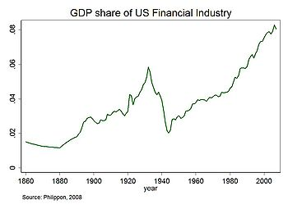

**Key Initiatives for Financial Inclusion:**

* **The Community Reinvestment Act (CRA):** Enacted in 1977, the CRA encourages banks to meet the credit needs of all communities within their service areas, including low- and moderate-income neighbourhoods.
* **The Bank on National Movement:** This initiative promotes the development of safe and affordable banking products targeted towards the unbanked and underbanked. These accounts typically have low or no minimum balance requirements and limited fees.

**Data Point:** According to the FDIC, over 1,800 banks and credit unions have partnered with the Bank On program as of 2023.

* **Financial Technology (FinTech):** FinTech companies are developing innovative solutions to reach underserved communities. Mobile banking apps and alternative lending platforms can provide financial services to those who may not have access to traditional banking channels.

**Challenges and Considerations:**

* **Regulatory Hurdles:** Regulations can sometimes create barriers for FinTech companies entering the financial services market. Balancing innovation with consumer protection is an ongoing challenge.
* **Digital Divide:** Limited access to reliable internet and smartphones can hinder the use of digital financial services, especially in rural areas. Efforts to bridge the digital divide are crucial for promoting financial inclusion.
* **Financial Literacy:** Many individuals lack the financial literacy skills necessary to make informed decisions about financial products and services. Educational initiatives can empower individuals to manage their finances effectively.

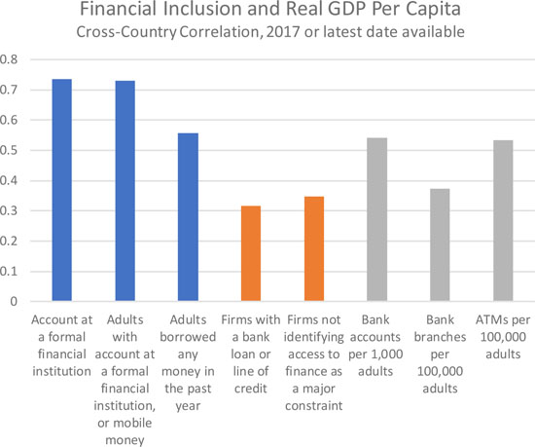

**The Road Ahead:**

Promoting financial inclusion requires a multi-pronged approach. Continued support for existing initiatives, coupled with fostering innovation in FinTech, addressing the digital divide, and promoting financial literacy, can all contribute to a more inclusive financial system in the US.

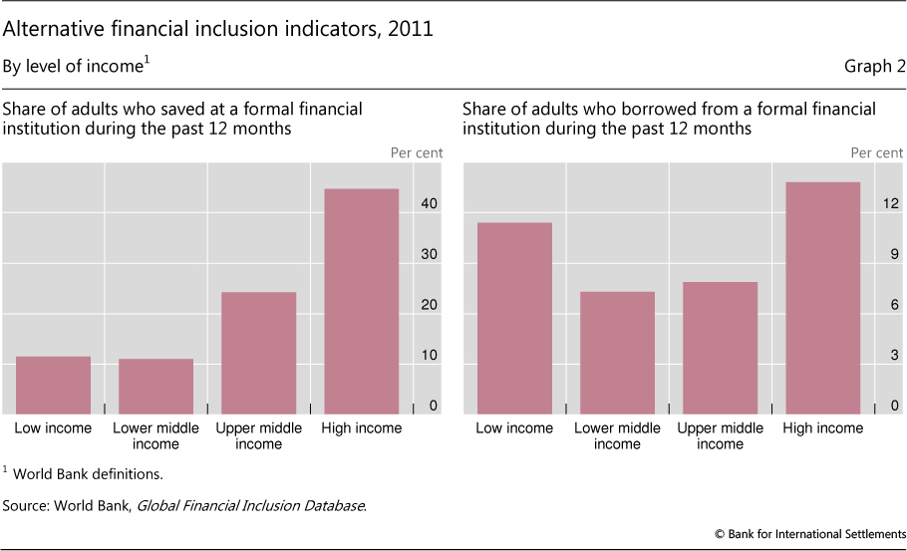

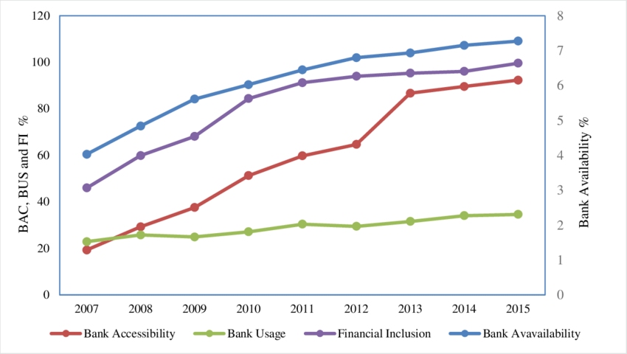

**3. Emerging Trends in the US Banking Sector**

**Introduction:**

The US banking sector is undergoing a period of significant transformation driven by technological advancements, changing consumer preferences, and a more competitive landscape. This report explores several key emerging trends that are shaping the future of US banking.

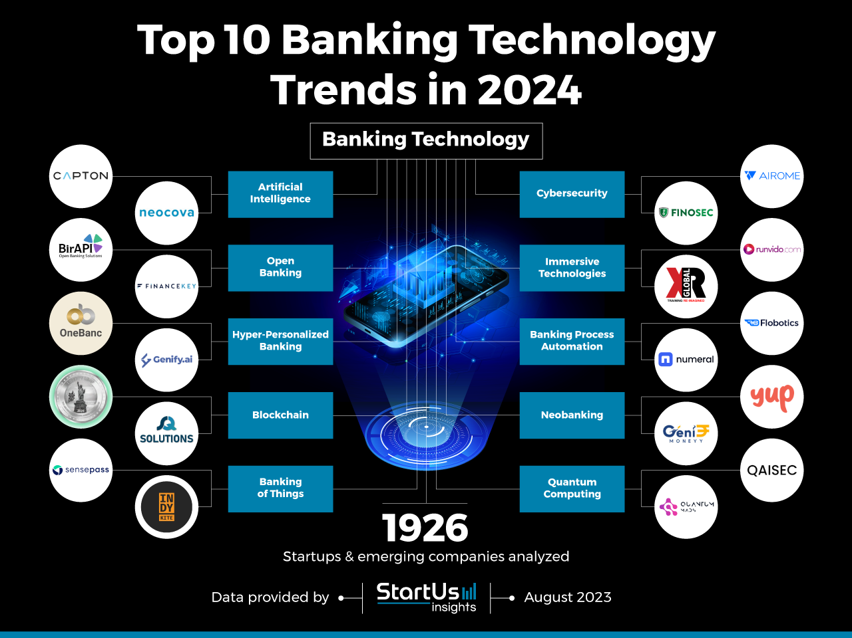

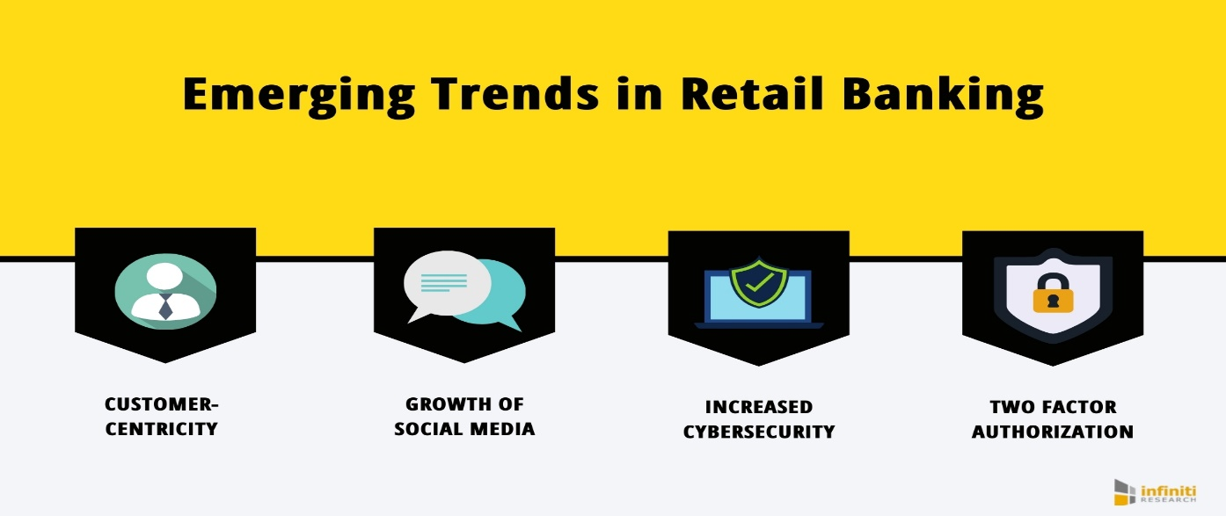

**1. Artificial Intelligence (AI) and Machine Learning (ML):**

* **Personalized Banking:** AI can analyse customer data to personalize financial products and services. This could include recommending suitable investment options, budgeting tools, or fraud alerts tailored to individual spending patterns.

**Data Point:** A study by Accenture predicts that AI could generate up to $3 trillion in additional revenue for the US banking sector by 2025.

* **Enhanced Customer Service:** AI-powered chatbots can provide 24/7 customer service, answer basic questions, and resolve simple issues, freeing up human representatives for more complex inquiries.
* **Automated Processes:** Machine learning can automate mundane tasks like loan application processing, fraud detection, and risk management, improving efficiency and reducing errors.

**2. Open Banking and APIs:**

* **FinTech Integration:** Open Banking allows third-party financial technology companies to access customer data (with permission) through APIs (Application Programming Interfaces). This fosters collaboration and innovation in the financial services industry.

**Data Point:** According to a report by EY, the global Open Banking market is expected to reach $43.15 billion by 2026, highlighting the significant growth potential of this trend.

* **Greater Choice and Flexibility:** Open Banking allows customers to compare financial products and services from different providers more easily and potentially benefit from more competitive rates and innovative solutions.
* **Data Security Concerns:** Open Banking raises questions about data privacy and security. Robust regulations and strong consumer protection measures are crucial to ensure responsible data sharing.

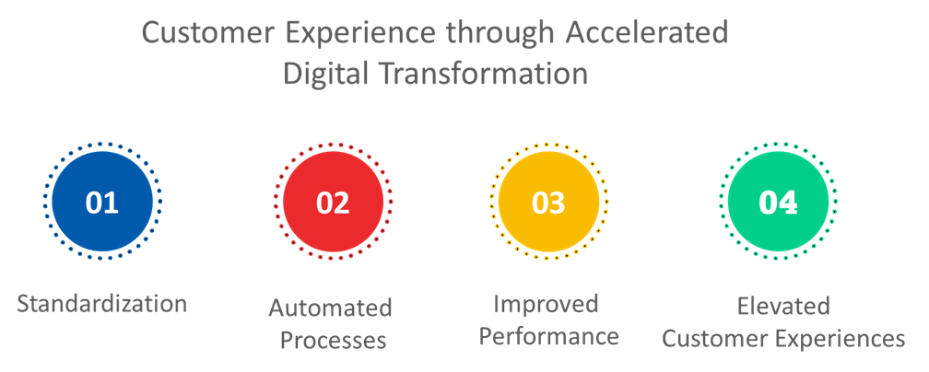

**3. Blockchain Technology:**

* **Secure Transactions:** Blockchain technology offers a secure and transparent way to record financial transactions. This could revolutionize areas like cross-border payments, trade finance, and recordkeeping.

**Case Study:** Several banks are exploring the use of blockchain for international transactions. For example, JPMorgan Chase has developed its own blockchain platform, JPM Coin, to facilitate faster and more efficient cross-border payments.

* **Improved Efficiency:** Blockchain can streamline processes by eliminating the need for intermediaries and reconciliation efforts, potentially saving time and costs.
* **Regulatory Hurdles:** Regulations around blockchain technology are still evolving. Clear legal frameworks are needed to ensure the widespread adoption and responsible use of this technology.

**4. The Rise of Cloud Computing:**

* **Scalability and Agility:** Cloud computing allows banks to scale their IT infrastructure up or down based on demand. This provides greater flexibility and agility to meet changing business needs.

**Data Point:** A study by Gartner predicts that by 2025, over 60% of bank IT spending will shift to cloud-based solutions.

* **Cost Savings:** Moving to the cloud can potentially reduce IT infrastructure costs for banks, freeing up resources for investments in innovation.
* **Security Concerns:** Security breaches in the cloud can have severe consequences. Banks need to choose reputable cloud service providers with robust security measures.

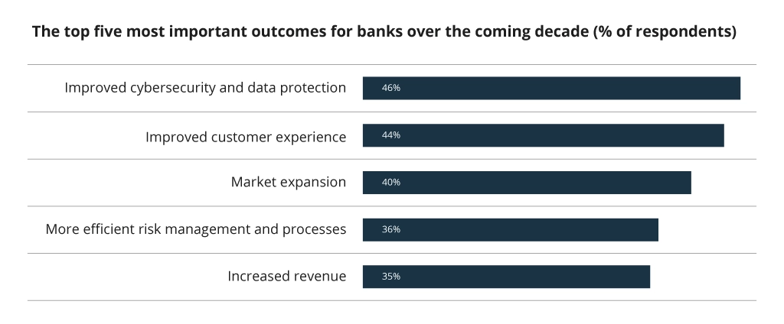

**The Road Ahead: A More Personalized and Frictionless Banking Experience:**

As these trends continue to develop, we can expect a future where banking becomes even more:

* **Personalized:** Financial institutions will leverage AI to anticipate customer needs and offer personalized financial advice or proactive solutions.
* **Convenient:** Biometric authentication (fingerprint, facial recognition) could become commonplace, enabling secure and seamless payments without the need for physical cards or codes.
* **Frictionless:** AI-powered tools could analyse spending patterns and provide personalized budgeting and saving recommendations.

**Challenges and Considerations:**

* **Ensuring Data Privacy and Security:** As technology advances, robust cybersecurity measures are essential to protect customer data from cyberattacks.
* **Promoting Financial Inclusion:** The digital divide can create barriers to accessing these new technologies. Efforts to bridge the digital divide are crucial for ensuring everyone benefits from these advancements.
* **The Evolving Role of Bank Employees:** While technology automates tasks, human interaction will likely remain vital for building trust, offering personalized advice, and navigating complex financial situations.

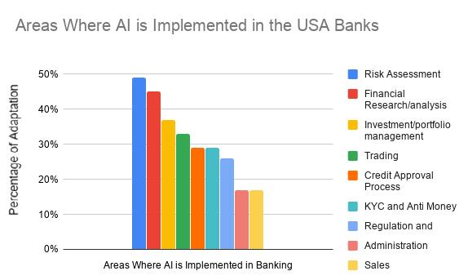

**Conclusion:**

The future of the US banking sector is brimming with innovation. Emerging technologies like AI, blockchain, and cloud computing hold immense potential to personalize services, enhance convenience, and improve efficiency. However, navigating this technological frontier requires addressing challenges like data security, promoting financial inclusion, and ensuring a human touch remains in banking. By embracing these trends responsibly and fostering collaboration, the US banking sector can create a future that is not only efficient and secure, but also empowering and inclusive for all.

